
SOURAV MAHANTA
E-mail : msouraav@gmail.com
Mobile : 9706924094

Objective:
To work in a globally competitive environment on challenging assignments that shall yield the twin benefits of job satisfaction and a steady-paced professional growth

Education Qualification:
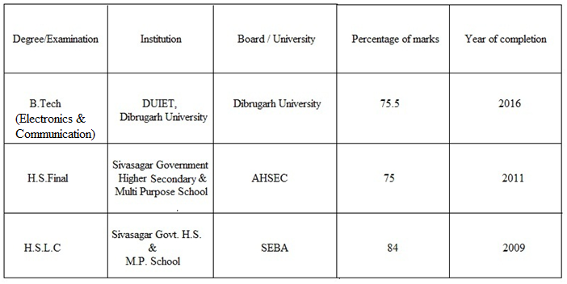

Academic Project:

Project Tittle: Innovative Power Harvesting Using Stepper Motor
Project Description: The main objective of the project is to generate clean electricity from freely available wheel power. We rectified the AC output of the Stepper motor by a voltage doubler circuit and the harvested power can be used to light up LEDs or can drive electronic components which consume low power.
Project Recognition: Manuscript entitled “Innovative Power Harvesting Using Stepper Motor” has published at “International Journal of Engineering Research and Application (IJERA)”

Industrial Training:
Company Name: Prasar Bharati Doordarshan Kendra, Guwahati
Training on “Television Broadcasting System”
Training Duration: 15 days

Technical Skills:

Language: C, C++
Simulation Tool: Matlab, Keil
Basic: Microsoft Word, Microsoft PowerPoint

Hobbies:

Reading novels, writing articles, playing Cricket, listening to soothing music, playing Sudoku etc.

Personal details:

- Language is known: English, Hindi, and Assamese
- Nationality: Indian
- Date of birth: 1st May 1993

Address: C/o: Mr. Girindra Kr. Mahanta
House Name: Aaitee Matrikaloi,
Sri Sri Jakai Satra, Na-Khana, Bezgaon,
Dist: Sivasagar, Assam

Date: 13th feb, 2017 Yours faithfully,

Place: Sivasagar Sourav Mahanta

